**(1).** How to compare two JSON have the same properties without order?

* 1. var obj1 = { name: "Person 1", age:5 };
  2. var obj2 = { age:5, name: "Person 1" };

**CODE:-**

**Output :-**

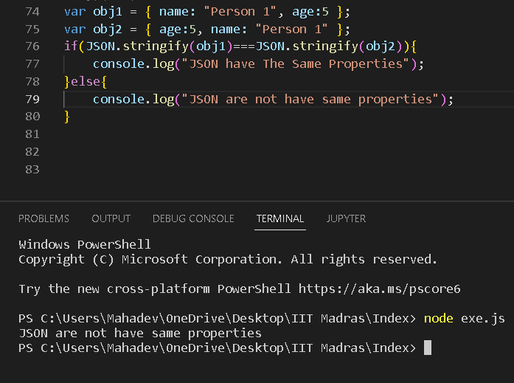

(2).Use the rest api and display the all country flag in console.

CODE:-

Var = new XMLHttpRequest();

url.open =(’GET’,“<https://raw.githubusercontent.com/rvsp/restcountries-json-data/master/res-countries.json>”);

xhr.onload = function(){

if(xhr.status>=250 && xhr.status<=300){

var data=JSON.parse(this.responceText);

//console.log(data);

For(let i=0;i<data.length;i++){

Console.log(data[i].flag);

}

} else{

Console.log(xhr.responseText);

}

};

Xhr.send();

**Output:-** 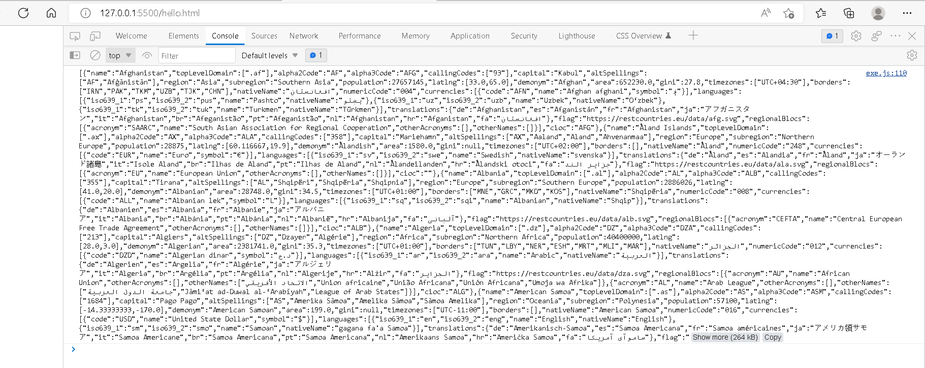

**(3)Use the rest country API and display all country population,name,sub-region and region .**

//set up a http request object

var xhr = new XMLHttpRequest();

xhr.open('GET',"https://raw.githubusercontent.com/rvsp/restcountries-json-data/master/res-countries.json");

xhr.onload = function() {

if(xhr.status >=250 && xhr.status< 300){

var data =JSON.parse(this.responseText);

console.log(data);

for(let i=0; i<data.length; i++){

console.log(data[i].name,data[i].region,data[i].sub-region,data[i].population);

}}

Else{

Console.log(xhr.responceText);

}

};

xhr.send();

OUTPUT:-

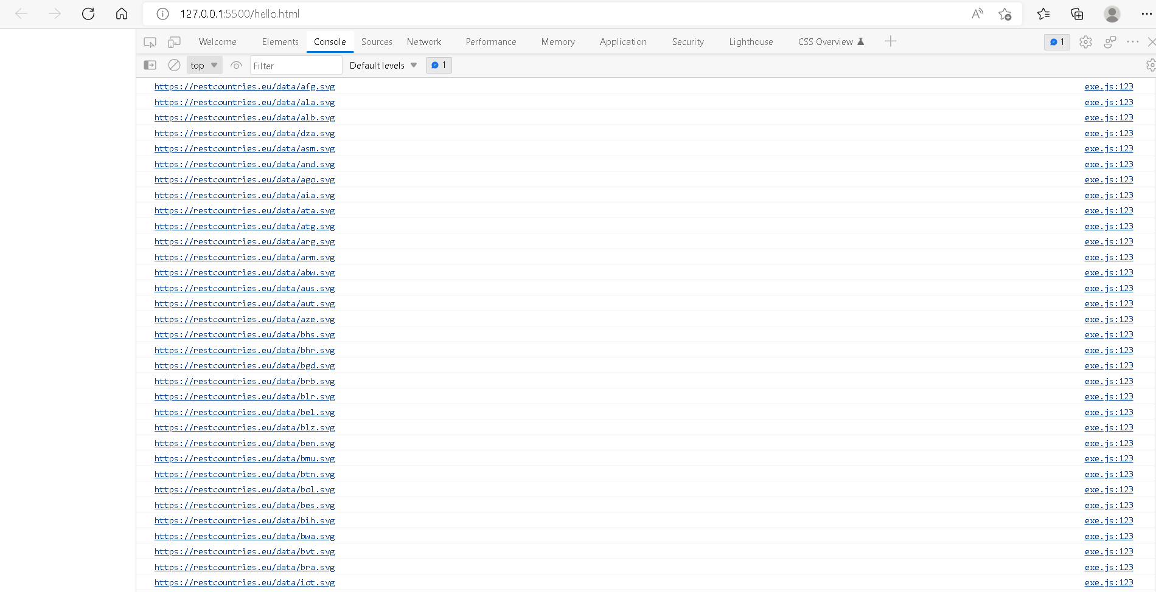

(4).Pratice :- Different Different Functions

Q-4

Ans:-

For practice:-

**1**.var myvar= 1;

console.log("myvar");

**2.**

let personData=[

{

firstname:"Rushiraj",

lastname:"Bhuva",

marital:"Savaliya",

Hobbies:"Music,Reading,Gaming,Cycling,Watch Movies",

Age:22,

Country:"india",

}

]

console.log(personData);

**3.Null type**

The Null type has exactly one value: null. See null and Null for more details.

Undefined type

A variable that has not been assigned a value has the value undefined. See undefined and Undefined for more details.

Numeric types

ECMAScript has two built-in numeric types: Number and BigInt — along with the related value NaN.

let let num = 16; // Number

let lastName = "Rushiraj"; // String

let x = {firstName:"Rushiraj", lastName:"Bhuva"}; // Object

**4.Convert mathod:-**

parseInt("60.5") //O.p 60

parseInt(22 year) //O.p 22

parseInt("He was 22") //O.p Nan

parseInt("45.25") //O.p 45

parseInt("20.00") //O.p 20

**5.**

1.ParseInt-code

myString = '111'

console.log(parseInt(myString)) // expected result: 111

2.using number()-code

a = 14.22

console.log(parseInt(a)) // expected result: 14

Number("15"); // returns 15

Number(" 25 "); // returns 25

Number("98.30"); // returns 98.30

3.unary()-code

const x = 25;

const y = -25;

console.log(+x); // expected output: 25

console.log(+y); // expected output: -25

console.log(+''); // expected output: 0

**6. True & False**

// all false

5 === '5';

9 === [9];

'3' === [3];

//all true

8 == '8';

11 == [11];

'20' == [20];

**7. square of number-code**

let x = Math.pow(5, 2);

**8. swaping of 2 number-code**

function swap(x, y) {

return [y, x];

}

console.log(swap(2, 3));

**9.Addition of 3 numbers-code**

let a=5;

let b=4;

let c=5;

console.log(a+b+c); //O.p 14

**10. F` to C`-code**

function temperatureConverter(valNum) {

valNum = parseFloat(valNum);

document.getElementById("outputCelsius").innerHTML = (valNum-32) / 1.8;

}

**11.Meter to miles-code**

#Taking user input

km = float(input("Enter value in kilometers: "))

#Conversion factor

cf = 0.621371

#Calculate miles

miles = km * cf

#Print the output

print('%0.2f kilometers is equal to %0.2f miles' %(kilometers,miles))

**12.Pounds to kg-code**

function weightConverter(valNum) {

document.getElementById("outputGrams").innerHTML = valNum / 0.0022046;

}

**13.Calculate Batting Average-code**

var sum = array.reduce((a, b) => a + b, 0); //get sum of all elements in array

var avg = (sum / array.length) || 0; //get average of all elements in array ;)

**14.Calculate five test scores and print their average-code**

var alpha = [['A', 80], ['B', 77], ['C', 88], ['D', 95], ['E', 68]];

var Avgmarks = 0;

for (var i=0; i < students.length; i++) {

Avgmarks += students[i][1];

var avg = (Avgmarks/alpha.length);

}

console.log("Average grade: " + (Avgmarks)/alpha.length);

if (avg < 60){

console.log("Grade : F");

}

else if (avg < 70) {

console.log("Grade : D");

}

else if (avg < 80)

{

console.log("Grade : C");

} else if (avg < 90) {

console.log("Grade : B");

} else if (avg < 100) {

console.log("Grade : A");

}

**15.code for square**

x^y =?

let b=Math.pow(5,9);

**16.Calculate Simple Interest-code**

const simpleInterest = document.querySelector('.simple-interest');

const button = document.querySelector('.button');

//const loading = document.querySelector('.loader');

const results = document.querySelector('.results');

function calculateResults(e) {

// ui elements

const principal = document.querySelector('#principal');

const rate = document.querySelector('#rate');

const time = document.querySelector('#time');

const monthlyPayment = document.querySelector('#payment');

const totalInterest = document.querySelector('#interest');

const totalAmount = document.querySelector('#total');

// formula variables

const p = parseFloat(principal.value);

const r = parseFloat(rate.value);

const t = parseFloat(time.value);

// calculate total interest

const interest = (p*t*r/100);

// calculate monthly payment

const payment = ((interest + p) / (t * 12)).toFixed(2);

// calculate total amount paid

const total = (interest + p).toFixed(2);

if (isFinite(payment)) {

totalInterest.innerHTML = '$' + (interest).toFixed(2);

monthlyPayment.innerHTML = '$' + payment;

totalAmount.innerHTML = '$' + total;

// hide loader

button.classList.remove('loading');

// show results

results.classList.remove('hide');

} else {

// show error

showError('Please check your numbers and try again.');

// hide loader

button.classList.remove('loading');

}

}

function showError(error) {

// create error

const errorMessage = document.createElement('div');

const calculate = document.querySelector('#calculate');

errorMessage.className = 'error';

errorMessage.appendChild(document.createTextNode(error));

simpleInterest.insertBefore(errorMessage, calculate);

// clear error

setTimeout(clearError, 3000);

}

function clearError() {

// remove error

document.querySelector('.error').remove();

}

button.addEventListener('click', (e) => {

console.log('Calculating...');

// show loader

button.classList.add('loading');

// set timeout

setTimeout(calculateResults, 2000);

// prevent page from reloading on submit

e.preventDefault();

});

/* IMPROVED OLD CODE BELOW */

// const button = document.querySelector('button');

// function simpleInterest() {

// console.log('Calculating...');

// //ui elements

// const p = parseFloat(document.querySelector('#principal').value);

// const r = parseFloat(document.querySelector('#rate').value);

// const t = parseFloat(document.querySelector('#time').value);

// const interest = document.querySelector('#interest');

// const payment = document.querySelector('#payment');

// const total = document.querySelector('#total');

// // calculate interest

// interest.innerHTML = '$' + (p*t*r/100).toFixed(2);

// // calculate monthly payment

// payment.innerHTML = '$' + (((p*t*r/100) + p) / (t * 12)).toFixed(2);

// // calculate total amount

// total.innerHTML = '$' + ((p*t*r/100) + p).toFixed(2);

// if(isFinite(payment)) {

// console.log('go');

// } else {

// console.log('error');

// }

// }

// button.addEventListener('click',simpleInterest);

**17.Find the area of triangle-code**

const baseValue = prompt('Enter the base of a triangle: ');// 6

const heightValue = prompt('Enter the height of a triangle: ');//4

// calculate the area

const areaValue = (baseValue * heightValue) / 2;//12

console.log(

`The area of the triangle is ${areaValue}`

);

**18.Area Of Isosceles Triangle-Code**

<script>

// Javascript program to find the Altitude

// Area of an isosceles triangle

// function to find the altitude

function altitude(a,b)

{

// return altitude

return Math.sqrt(Math.pow(a, 2) - (Math.pow(b, 2) / 4));

}

// function to find the area

function area( b, h)

{

// return area

return (1 * b * h) / 2;

}

// Main code

let a = 2, b = 3;

let h = altitude(a, b);

document.write("Altitude= " + h.toFixed(2) + ", ");

document.write( "Area= " + area(b, h).toFixed(2));

**19.volume of sphere-code**

function calc(){

let number=document.getElementById("radius").value;

number=Number(number);

// The formula for the volume of a sphere (4. π. r*r*r )/ 3

let sphere=(4*Math.PI*number*number*number)/3;

//Cut the floating digits to two float

sphere =sphere .toFixed(2);

alert("The volume of a sphere: "+sphere);

}

let btnCalc=document.getElementById("btnCalc");

btnCalc.onclick=calc;

**20.Volume Of Prism-code**

// function to find the Volume

// of triangular prism

function findVolume( l, b, h)

{

// formula to find Volume

let volume = (l * b * h) / 2;

return volume;

}

// Main Code

let l = 18, b = 12, h = 9;

// function calling

document.write( "Volume of triangular prism: " + findVolume(l, b, h));

**21.Find area of triangle-code**

//JavaScript Program To Calculate The Area of a Triangle

var base = parseInt(prompt("Enter the base: "));

var height = parseInt(prompt("Enter the height: "));

//Calculating the area

var area = (base * height) / 2;

//Display Output

console.log("Base: " + base);

console.log("Height: " + height);

console.log("The area of the triangle is " + area);

**22.Give the Actual cost and Sold cost, Calculate Discount Of Product-code**

getPrice = function() {

var numVal1 = Number(document.getElementById("price").value);

var numVal2 = Number(document.getElementById("discount").value) / 100;

var totalValue = numVal1 - (numVal1 * numVal2)

document.getElementById("total").value = totalValue.toFixed(2);

}

**23.Given their radius of a circle and find its diameter, circumference and area. code:-**

function circle(radius)

{

this.radius = radius;

// area method

this.area = function ()

{

return Math.PI * this.radius * this.radius;

};

// perimeter method

this.perimeter = function ()

{

return 2*Math.PI*this.radius;

};

}

var c = new circle(3);

console.log('Area =', c.area().toFixed(2));

console.log('perimeter =', c.perimeter().toFixed(2));

**24.Given two numbers and perform all arithmetic operations:-code**

1)

Math.round(a) Returns a rounded to its nearest integer.

2)

Math.ceil(b) Returns b rounded up to its nearest integer.

3)

Math.floor(c) Returns c rounded down to its nearest integer.

4)

Math.trunc(d) Returns the integer part of d.

5)

Math.round(4.6) returns the nearest integer.//o.p=5

6)

Math.ceil(5.9) returns the value of x rounded up to its nearest integer://o.p=6

7)

Math.floor(4.2) returns the value of x rounded down to its nearest integer://0.p=4

8)

Math.pow(5, 5) returns the value of x to the power of y://o.p=3125//5^5

9)

Math.sqrt(25) returns the square root of x://o.p=5

10)

Math.min() and Math.max() can be used to find the lowest or highest value in a list of arguments:

11)

Math.random() returns a random number between 0 (inclusive), and 1 (exclusive):

12)

Math.log(f) returns the natural logarithm of x.

13)

Math.log2(g) returns the base 2 logarithm of x.

14)

Math.log10(h) returns the base 10 logarithm of x.

15)

Math.abs(i) returns the absolute (positive) value of x:

16)

Math.sin(x) returns the sine (a value between -1 and 1) of the angle x (given in radians).

17)

Math.cos(x) returns the cosine (a value between -1 and 1) of the angle x (given in radians).